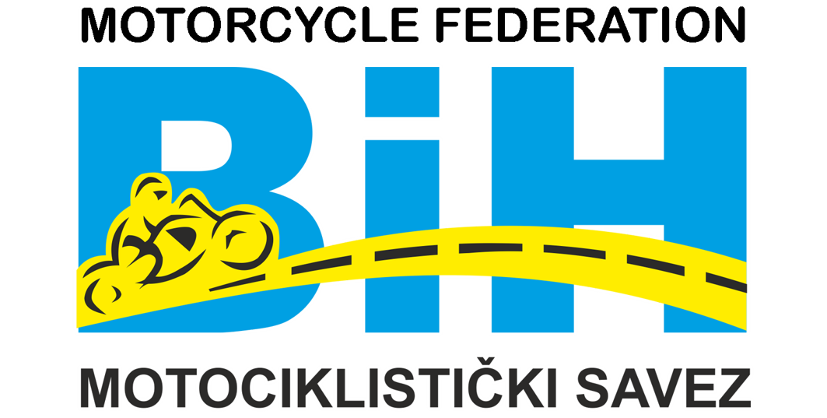 | Motorcycle Federation of Bosnia&Herzegovina  St. Fra-Grge Martica 127, 71260 Kresevo, B&H  E-mail: motosavezbih@gmail.com  www.msbih.ba | 

Anex 7-11

Na osnovu/temelju Odredbi Sportskog motociklističkog pravilnika MS BiH, koristim pravo i dajem,

I Z J A V U

Ja _______________________, izjavljujem da u sezoni ____, ne posjedujem vozačku licencu druge države, niti imam bilo kakvih formalno-pravnih obaveza prema prema drugom klubu ili savezu druge države.

In according to Sports Motorcycle regulations of the MS BiH, I use the right and give,

S T A T E M E N T

I _______________________, declare that in the season ____, I don’t have a rider's license from another country, and I don’t have any formal-legal obligations towards another club or federation from another country.

U ______________, ______20__.g.

_________________
(potpis)

